Gazebo Hire Contract and Booking Form

- Panama 2 x 2m waterproof* Pop Up gazebo (Black)

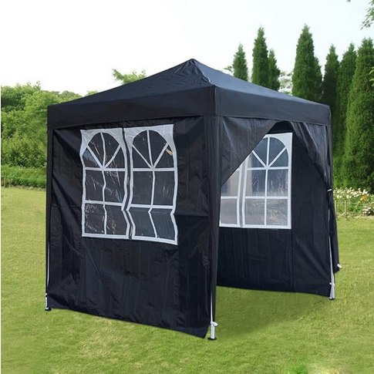
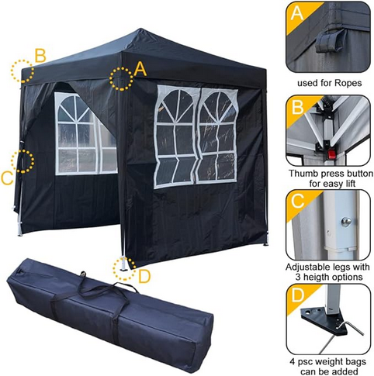

Price
£20 for up to a week’s hire

Dimensions for transport

Gazebo bag 1.2m x .20m x .2

Dimensions in use
2m x 2m but allow 3m x 3m with guy ropes

We supply:
Gazebo Bag containing:

- Frame with roof canopy and guy ropes attached (Guy ropes and ground spikes/ tent pegs to be used on grass only)
- 2x Window sides + 1x plain side + 1x plain side with middle zip opening.
In addition:
- 8-12 x Tent Pegs/ Ground Spikes
- 1 mallet if required
- Water weights for use on concrete, subject to availability

You need
- Vehicle transport
- At least two people to put it up
*This gazebo is not recommended for use in very heavy rain and/or high winds as rain may blow in through the sides.
- Panama 2 x 2m waterproof* Pop Up gazebo (Beige)

Price
£20 for up to a week’s hire

Dimensions for transport

Gazebo bag 1.2m x .20m x .2

Dimensions in use
2m x 2m but allow 3m x 3m with guy ropes

We supply
Gazebo Bag containing:

- Frame with roof canopy and guy ropes attached (Guy ropes and ground spikes/ tend pegs to be used on grass only)
- 2x Window sides + 1x plain side + 1x plain side with middle zip opening.
In addition:
- 8x Tent Pegs/ Ground Spikes
- 1 mallet if required
- Water weights for use on concrete, subject to availability

You need
- Vehicle transport
- At least two people to put it up
*This gazebo is not recommended for use in very heavy rain and/or high winds as rain may blow in through the sides.

- Leadyeh Pop Up gazebo 3m x 3m Waterproof and UV Protection (Blue)
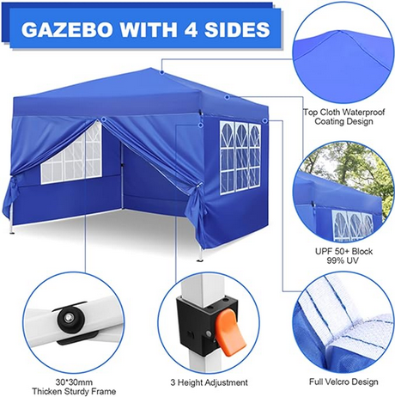

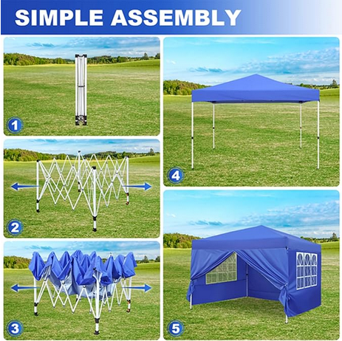

Price
£30 for up to a week’s hire

Dimensions for transport

Gazebo bag 1.2m x .20m x .20m + 1 large box

Dimensions in use
3m x 3m but allow 4m x 4m with guy ropes

We supply
- Gazebo Bag containing:
- Frame with roof canopy and guy ropes attached (Guy ropes and ground spikes/ tend pegs to be used on grass only)
- One “large” labelled box:
- 2x Window sides.
- 1x plain side
- 1x plain side with middle zip opening.
In addition:
- 8x Tent Pegs/ Ground Spikes
- 4x Water Weights for use on hard standing
- 1 mallet if required

You need
- Vehicle transport
- At least three people to put it up

- COBIZI Pop Up waterproof gazebo 3m x 3m (Green)
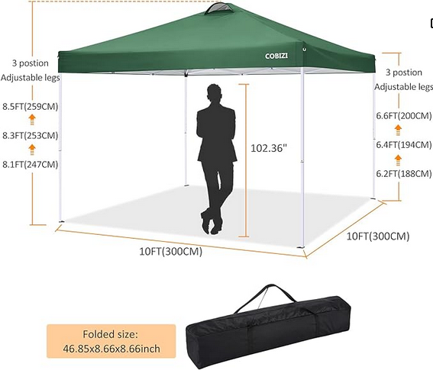

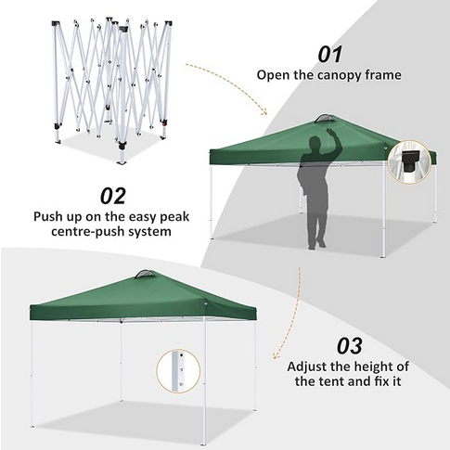

Price
£30 for up to a week’s hire

Dimensions for transport

Gazebo bag 1.2m x .20m x .20m + 1 large box

Dimensions in use
3m x 3m but allow 4m x 4m with guy ropes

We supply
- Gazebo Bag containing:
- Frame with roof canopy and guy ropes attached (Guy ropes and ground spikes/ tend pegs to be used on grass only)
- One “large” labelled box:
- 2x Window sides.
- 1x plain side
- 1x plain side with middle zip opening.
In addition:
- 8x Tent Pegs/ Ground Spikes
- 4x Water Weights for use on hard standing
- 1 mallet if required

You need
- Vehicle transport
- At least three people to put it up

Terms and Conditions of Hire
1. It is the hirer’s responsibility to keep the items in a suitable condition for re-hire.
2. A returnable deposit of £50 is required per hire period unless more than two items are required, in which case an increased deposit may be payable.
3. Hire payment and deposit is by cleared funds received at least two working days prior to hire.
4. Any loss or damage must be notified immediately and your deposit may be partially or completely forfeit. Lost or damaged items must be paid for, the cost of which may exceed your deposit so that an additional charge will be made.
5. When erected all safety measures must be in place to ensure the structural integrity of the gazebo (i.e. guy ropes and ground spikes/ tent pegs MUST be used if on grass and the water weights MUST be in use if on hard standing.
6. It is the hirer’s responsibility to ensure the safety of people erecting the gazebos and we take no responsibility for any injury which may occur.
7. The booking form and signature forms the hire contract and use of the items must accord with details given, e.g. when, where and how the item is to be used. All items must be stored securely when not in use.
8. Hirers must adhere to collection and return times given. Collections from and returns to are to the address on this contract.
Payment:
- Payment preference is via bank transfer payable to:

Ms J Taylor (Personal account)
First Direct
Sort Code: 40-47-75
Account Number: 94361547
Reference: *Your Name*/Business Name

- Arrangements can be made for cash or cheque payments up to 3 days before collection

Cancellations:
- No refunds will be offered unless In exceptional circumstances, e.g. serious illness or extreme weather, where we will use our discretion.
General Data Protection Regulations:
- By completing the booking from, you give consent that Ms J Taylor can process the data provided for hire purposes only. Hirers can remove themselves from our customer database at any time.
Booking Form

Full Contact Name:
Business/ Charity Name: (If applicable)
Home address:

Address where the item(s) will be used (if different to Home):

Surface on which the item will be used: Concrete or grass?

Address where the item(s) will be stored (if different to Home)

Contact Email Address:
Contact Mobile Phone number:
Date(s) of Hire:

Items required | £
Panama 2m x 2m pop up gazebo (Black)
Panama 2m x 2m pop up gazebo (Beige)
Leadyeh 3m x3m pop up gazebo (Blue)
Cobizi 3m x3m pop up gazebo (Green)
Additional items:
Table 2m x 0.5m: @ £9
Chairs with arms (plastic) @ £2.50
Total to pay

…………………………………………………………………………………………………
For Office Use Only
Payment Received:
Collection date and time:

Return date and time:

